**SOFTWARE REQUIREMENTS SPECIFICATION (SRS) DOCUMENT**

**Project Name: Inventory Management System (IMS)**

**Date: 22nd March, 2025**

**Authors:**

**NAME: SANDE MOSES**

**REG NO: JAN23/BSE/2405U**

**NAME: WAMBEDE IBRAHIM**

**REG NO: MAY23/BSE/3167U**

Contents

1. Introduction 4

1.1 Purpose 4

1.2 Scope 4

1.3 Definitions, Acronyms, and Abbreviations 4

1.4 References 4

1.5 Overview 4

2. Overall Description 4

2.1 Product Perspective 4

2.2 Product Functions 4

2.3 User Characteristics 4

2.4 Constraints 4

2.5 Assumptions and Dependencies 4

3. Specific Requirements 4

3.1 Functional Requirements 4

3.1.1 User Authentication 4

3.1.2 Product Management 4

3.1.3 Sales Management 5

3.2 Non-Functional Requirements 5

3.2.1 Performance 5

3.2.2 Security 5

3.2.3 Usability 5

3.3 System Attributes 5

3.3.1 Reliability 5

3.3.2 Maintainability 5

3.3.3 Portability 5

4. Other Requirements 5

4.1 Database Requirements 5

4.2 Interface Requirements 5

4.3 Legal Requirements 6

4.4 Documentation Requirements 6

5. Activity Diagram 7

Use Case diagram 8

Sequence Diagram 8

Entity Relationship Diagram 9

Data Flow Diagram 10

6. Conclusion 10

# 1. Introduction

## 1.1 Purpose

The purpose of this document is to outline the requirements for the development of a web-based application for managing products, sales, and generating receipts. The application will allow users to register, log in, manage products, record sales, and generate printable receipts.

## 1.2 Scope

The application will be developed using the Flask framework and will include features such as user authentication, product management, sales recording, and receipt generation. The application will be designed to be user-friendly and will provide a secure environment for managing business operations.

## 1.3 Definitions, Acronyms, and Abbreviations

* Flask: A micro web framework written in Python.

* SQLAlchemy: A SQL toolkit and Object-Relational Mapping (ORM) library for Python.

* WTForms: A flexible forms validation and rendering library for Python web development.

* Bcrypt: A password hashing function used for secure password storage.

* UUID: Universally Unique Identifier, used for generating unique filenames.

## 1.4 References

* Flask Documentation:áhttps://flask.palletsprojects.com/

* SQLAlchemy Documentation:áhttps://www.sqlalchemy.org/

* WTForms Documentation:áhttps://wtforms.readthedocs.io/

* Bcrypt Documentation:áhttps://pypi.org/project/bcrypt/

## 1.5 Overview

The document is organized into sections that describe the overall description, specific requirements, and other relevant information about the application.

# 2. Overall Description

## 2.1 Product Perspective

The application is a standalone web-based system that will be accessed through a web browser. It will interact with a SQLite database to store user information, product details, and sales records.

## 2.2 Product Functions

* User registration and authentication.

* Product management (add, edit, delete, search).

* Sales recording and receipt generation.

* Viewing and printing sales receipts.

## 2.3 User Characteristics

The primary users of the application will be business owners or managers who need to manage their inventory and sales. Users should have basic computer literacy and be familiar with web-based applications.

## 2.4 Constraints

* The application will be developed using Python and Flask.

* The database will be SQLite.

* The application will be designed to run on a local server.

## 2.5 Assumptions and Dependencies

* Users will have access to a modern web browser.

* The application will be hosted on a server with Python and Flask installed.

* The application will depend on the Flask extensions: Flask-Login, Flask-WTF, Flask-SQLAlchemy, and Flask-Bcrypt.

# 3. Specific Requirements

## 3.1 Functional Requirements

## 3.1.1 User Authentication

* FR1: The system shall allow users to register with a unique username and password.

* FR2: The system shall allow registered users to log in using their credentials.

* FR3: The system shall allow logged-in users to log out.

## 3.1.2 Product Management

* FR4: The system shall allow logged-in users to add new products with details such as name, description, cost price, sale price, quantity, and image.

* FR5: The system shall allow logged-in users to edit existing product details.

* FR6: The system shall allow logged-in users to search for products by name or description.

## 3.1.3 Sales Management

* FR7: The system shall allow logged-in users to record sales, including buyer name, product details, quantity, and total amount.

* FR8: The system shall generate a printable receipt for each sale.

* FR9: The system shall allow logged-in users to view and print previously generated receipts.

## 3.2 Non-Functional Requirements

## 3.2.1 Performance

* NFR1: The system shall handle up to 100 concurrent users without significant performance degradation.

* NFR2: The system shall load product listings within 2 seconds under normal conditions.

## 3.2.2 Security

* NFR3: The system shall store user passwords securely using bcrypt hashing.

* NFR4: The system shall prevent unauthorized access to sensitive pages (e.g., dashboard, product management).

## 3.2.3 Usability

* NFR5: The system shall provide a user-friendly interface with clear navigation and instructions.

* NFR6: The system shall be accessible via modern web browsers (Chrome, Firefox, Edge).

## 3.3 System Attributes

## 3.3.1 Reliability

* The system shall be available 99% of the time during business hours.

* The system shall recover from errors gracefully without data loss.

## 3.3.2 Maintainability

* The system shall be designed with modular code to facilitate future updates and maintenance.

* The system shall include logging for debugging and monitoring purposes.

## 3.3.3 Portability

* The system shall be deployable on any server that supports Python and Flask.

* The system shall use a SQLite database, which is portable and requires no additional setup.

# 4. Other Requirements

## 4.1 Database Requirements

* The system shall use a SQLite database to store user information, product details, and sales records.

* The database schema shall include tables for Users, Products, and Sales.

## 4.2 Interface Requirements

* The system shall provide a web-based interface accessible via a browser.

* The interface shall include forms for user registration, login, product management, and sales recording.

## 4.3 Legal Requirements

* The system shall comply with data protection regulations regarding the storage and handling of user data.

* The system shall not store sensitive information such as credit card details.

## 4.4 Documentation Requirements

* The system shall include user documentation explaining how to register, log in, manage products, and record sales.

* The system shall include technical documentation for developers, including setup instructions and API documentation.

# 5. Activity Diagram

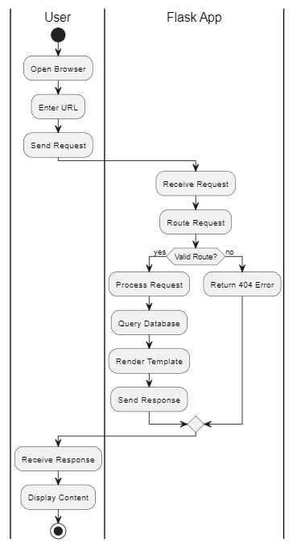

## Use Case diagram



## Sequence Diagram

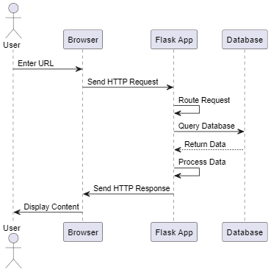

## Entity Relationship Diagram

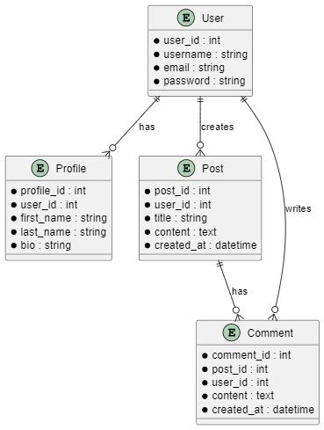

## Data Flow Diagram

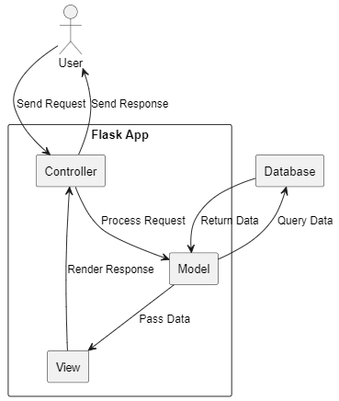

# 6. Conclusion

This SRS document outlines the requirements for the development of a web-based application for managing products, sales, and generating receipts. The document covers functional and non-functional requirements, system attributes, and other relevant information necessary for the successful development and deployment of the application.